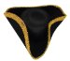Lions Club of Lexington –
Official Tricorn Hats
Adult Hats $35 *

~~~~~~~~~~~~~~~
Sizes & Order Form

100% wool
Adult Hat
100% Wool
Head Circumference
Inches | Centimeters | Adult  Sizes | Youth  Size
21 1/4 | 54 | 6 ¾ | Small (S)
21 5/8 | 55 | 6 7/8
22 | 55.9 | 7 | Medium (M)
22 3/8 | 56.8 | 7-1/8
22 3/4 | 57.8 | 7-1/4 | Large (L)
23 1/8 | 58.7 | 7 3/8
23 1/2 | 59.7 | 7 ½ | XL
23 7/8 | 60.6 | 7 5/8
24 1/4 | 61.6 | 7 3/4
24 5/8 | 62.5 | 7 7/8

Youth Hats $8*

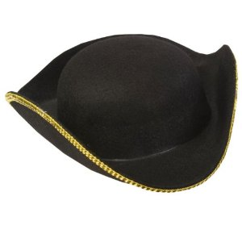

------------------------------------------------------------------------------------------------------------
* Shipping Charge: Add $12 for 1st hat, $5 each additional hat.
If you prefer to pick up your order, you may pay at that time. Call or email us at lexlionsclub@gmail.com to make arrangements.
Tricorne Hat Order Form – Lexington Lions
Date: _________________
Name: ____________________________________ Phone Number: __________________
Address: ______________________________________________________________________
City, State, Zip: ______________________________________________
Email address for order confirmation & delivery timing: ________________________________
Adult Hats ($35 per hat) Youth hats ($8 per hat)
Total Order
Amount
$ _________
Shipping Charges: $12 for 1st hat, $5 each additional hat.
Size | Qty | Total $ |  | Size | Qty | Total $
6 ¾ |  |  |  | Small
6 7/8 |  |  |  | Medium
7 |  |  |  | Large
7 1/8 |  |  |  | X-Large
7 ¼
7 3/8
7 ½
7 5/8
7 ¾
7 7/8
Totals |  | $ |  |  |  | $
Mail this order form with a check (payable to Lexington Lions) to: 781-862-4710
Lexington Lions Hats, PO Box 71, Lexington MA 02420 www.lexingtonlions.org

